Exercise 1.

Create a file Exercise1.js:

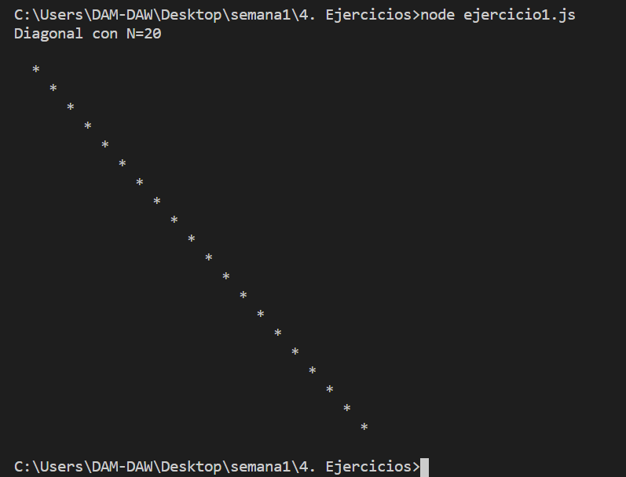

Exercise 2.

Create a file exercise2.js:

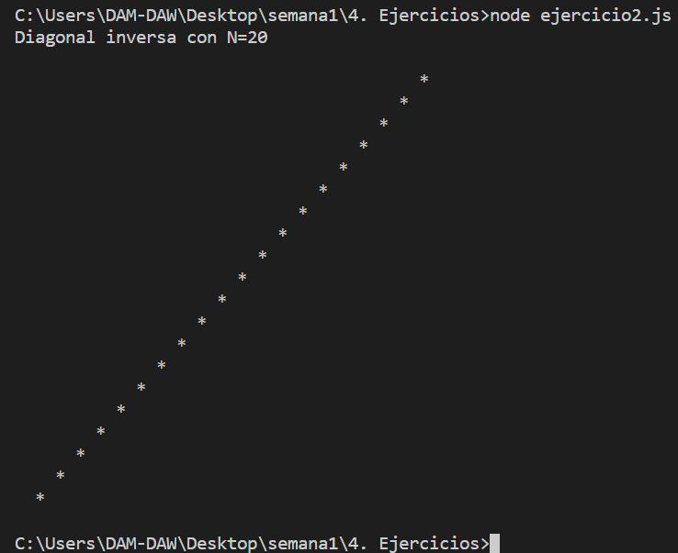

Exercise 3.

Create exercise.js:

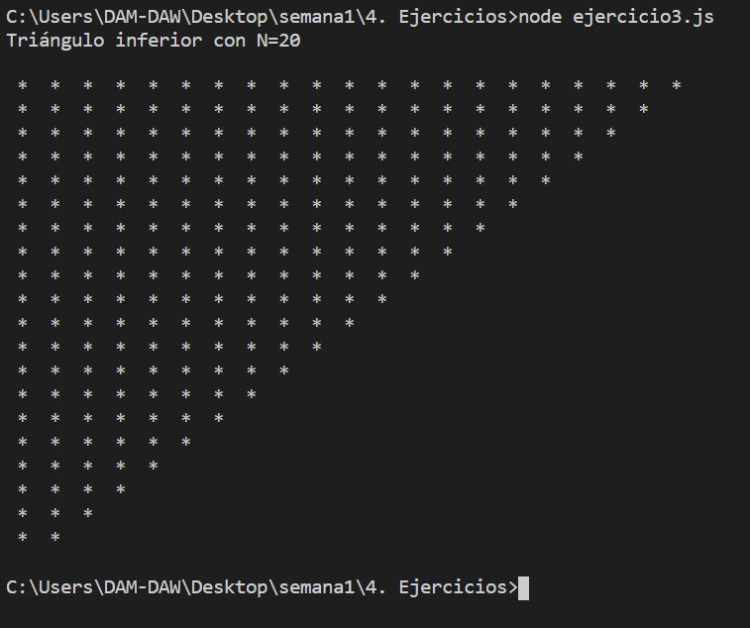

Exercise 4.

Create exercise4.js:

